

**Product dissection of Amazon**

**Company overview:**

Amazon was founded on July 5, 1994, by Jeff Bezos in Bellevue[,](https://en.wikipedia.org/wiki/Bellevue,_Washington) Washington.The company originally started as an online marketplace for books but gradually expanded its offerings to include a wide range of product categories. This diversification led to it being referred to as "The Everything Store".

### **Product Dissection and Real-World Problems Solved by Amazon:**

In the context of Amazon or similar large-scale e-commerce platforms, a product dissection involves breaking down a product into its various components and attributes to manage and display it effectively on the platform. This dissection helps in categorizing, searching, and presenting products to customers. Here's a detailed breakdown of how a product might be dissected:

Amazon has addressed numerous real-world problems with its wide range of services and innovations. Here are several key problems Amazon has solved:

### **1. Convenience and Accessibility**

**Problem:** Shopping required physical store visits, which could be time-consuming and inconvenient.

**Solution:** Amazon introduced online shopping, allowing customers to browse, compare, and purchase products from the comfort of their homes. This solved the problem of geographical constraints and time limitations, providing 24/7 access to a vast selection of goods.

### **2. Product Variety and Availability**

**Problem:** Physical stores often have limited space and inventory, restricting product availability and variety.

**Solution:** Amazon's online platform allows for an extensive inventory, including millions of products across countless categories. This vast selection means customers are more likely to find the exact product they want, even niche or hard-to-find items.

### **3. Fast and Reliable Delivery**

**Problem:** Traditional shipping methods could be slow, with long delivery times and uncertainties about arrival dates.

**Solution:** Amazon has revolutionized logistics with innovations such as same-day and next-day delivery through Amazon Prime, and a vast network of fulfillment centers. The company has also invested in advanced technologies like robotics and AI to streamline warehouse operations and delivery processes.

### **4. Price Comparison and Cost Savings**

**Problem:** Comparing prices across different stores could be laborious and inconvenient.

**Solution:** Amazon's platform allows customers to easily compare prices across various sellers. Features such as price tracking, deal recommendations, and user reviews help customers find the best deals and make informed purchasing decisions.

### **5. Scalability for Small Businesses**

**Problem:** Small businesses and individual sellers often struggled to reach a broad audience and manage logistics.

**Solution:** Amazon provides a marketplace where small businesses and individual sellers can list their products and reach millions of potential customers. Services like Fulfillment by Amazon (FBA) allow these sellers to leverage Amazon’s logistics network for warehousing and shipping, enabling them to scale without significant infrastructure investments.

### **6. Personalized Shopping Experience**

**Problem:** Shoppers often faced difficulty finding products that match their preferences and previous purchases.

**Solution:** Amazon uses sophisticated algorithms to provide personalized recommendations based on browsing history, previous purchases, and customer behavior. This personalized shopping experience helps customers discover new products and enhances overall satisfaction.

### **7. Digital Content Distribution**

**Problem:** Access to digital content like books, movies, and music was limited by physical media and store locations.

**Solution:** Amazon expanded into digital content with services like Kindle eBooks, Amazon Prime Video, and Amazon Music. This provides instant access to a wide range of digital media from anywhere, solving the problem of physical media limitations and distribution.

### **8. Cloud Computing Needs**

**Problem:** Businesses required scalable and flexible computing resources but faced challenges with on-premises infrastructure management.

**Solution:** Amazon Web Services (AWS) provides a comprehensive suite of cloud computing services, including computing power, storage, and databases. AWS has transformed how businesses approach IT infrastructure, offering scalability, flexibility, and cost efficiency.

### **9. Supply Chain Optimization**

**Problem:** Managing and optimizing supply chains could be complex and inefficient, particularly for large-scale operations.

**Solution:** Amazon has developed a highly optimized and efficient supply chain and logistics network. This includes predictive analytics for inventory management, advanced warehousing technologies, and a sophisticated delivery system that reduces costs and improves speed.

### **10. Customer Service and Support**

**Problem:** High-quality customer service was often inconsistent, and resolving issues could be frustrating and time-consuming.

**Solution:** Amazon emphasizes customer service, offering a range of support options including easy returns, comprehensive customer service channels, and a straightforward refund process. This commitment to customer satisfaction helps build trust and loyalty.

### **Conclusion**

Amazon's solutions to these problems have not only disrupted traditional retail but also set new standards for customer expectations and business operations. By leveraging technology, data analytics, and a relentless focus on customer needs, Amazon has addressed numerous challenges and continues to innovate in various areas to solve emerging problems.

**Top Features of Amazon:**

Amazon offers a diverse range of features across its various services and platforms. Here are some of the top features that distinguish Amazon and contribute to its success:

### **1. Extensive Product Selection**

* **Vast Inventory**: Amazon provides a comprehensive range of products across numerous categories including electronics, clothing, books, groceries, and more.

### **2. Prime Membership**

* **Free Shipping**: Members enjoy free two-day shipping on eligible items, with options for same-day or one-day delivery in certain locations.
* **Prime Video**: Access to a large library of movies, TV shows, and original content.
* **Prime Music**: Streaming access to a vast catalog of music.
* **Prime Reading**: Borrow eBooks and magazines from the Prime Reading catalog.
* **Early Access**: Early access to Lightning Deals and exclusive promotions.

### **3. Advanced Search and Filters**

* **Search Functionality**: Powerful search capabilities with auto-complete suggestions and related searches.
* **Filters and Sorting**: Detailed filters and sorting options to narrow down search results based on attributes like price, brand, rating, and more.

### **4. Customer Reviews and Ratings**

* **User Reviews**: Detailed reviews and ratings from other customers provide insights into product quality and performance.
* **Q&A Section**: Customers can ask questions and get answers from other users or the seller.

### **5. Amazon Web Services (AWS)**

* **Cloud Computing**: AWS provides a suite of cloud computing services, including computing power, storage, and databases, supporting a wide range of business needs.
* **Scalability and Flexibility**: AWS allows businesses to scale their infrastructure easily and manage resources efficiently.

### **6. Alexa and Smart Home Integration**

* **Voice Assistant**: Amazon's Alexa is a voice-controlled assistant that can perform tasks, provide information, and control smart home devices.
* **Smart Devices**: Integration with a wide range of smart home products such as lights, thermostats, and security cameras.

### **7. Customer Service and Returns**

* **Easy Returns**: Simple and straightforward return process with options for return shipping or drop-off at various locations.
* **24/7 Customer Support**: Access to customer service through multiple channels including chat, email, and phone.

### **Schema Description:**

Designing a schema for a complex platform like Amazon involves many components, reflecting the diverse functionality and data relationships within the system. Here's a high-level overview of a possible schema design for an e-commerce platform like Amazon:

1. **Users and Authentication:**

- **Users**

- `user_id` **(Primary Key)**

- `username`

- `password_hash`

- `email`

- `phone_number`

- `created_at`

- `updated_at`

- **User_Profile**

- `user_id` (**Primary Key**, **Foreign Key**)

- `first_name`

- `last_name`

- `address_line1`

- `city`

- `state`

- `postal_code`

- `country`

- `profile_picture_url`

**2. Products and Inventory**

- **Products**

- `product_id` **(Primary Key)**

- `name`

- `description`

- `category_id` (**Foreign Key**)

- `brand_id` (**Foreign Key**)

- `price`

- `rating`

- `created_at`

- `updated_at`

**- Product_Inventory**

- `product_id` (**Primary Key**, **Foreign Key**)

- `quantity_in_stock`

- `warehouse_id` (**Foreign Key**)

- **Product_Images**

- `image_id` **(Primary Key)**

- `product_id` (**Foreign Key**)

- `image_url`

- `alt_text`

- **Categories**

- `category_id` **(Primary Key)**

- `category_name`

- `parent_category_id` (**Foreign Key**, nullable)

- **Brands**

- `brand_id` **(Primary Key)**

- `brand_name`

3. **Sales and Orders**

- **Orders**

- `order_id` **(Primary Key)**

- `user_id` (**Foreign Key**)

- `order_status`

- `order_date`

- `total_amount`

- `shipping_address_id` (**Foreign Key**)

- **Order_Items**

- `order_item_id` **(Primary Key)**

- `order_id` (**Foreign Key**)

- `product_id` (**Foreign Key**)

- `quantity`

- `unit_price`

- **Shipping_Addresses**

- `shipping_address_id` **(Primary Key)**

- `user_id` (**Foreign Key**)

- `address_line1`

- `address_line2`

- `city`

- `state`

- `postal_code`

- `country`

**4. Reviews and Ratings**

- **Product_Reviews**

- `review_id` **(Primary Key)**

- `product_id` (**Foreign Key**)

- `user_id` (**Foreign Key**)

- `rating` (e.g., 1-5 stars)

- `review_text`

- `created_at`

- **Product_Ratings**

- `product_id` (**Primary Key**, **Foreign Key**)

- `average_rating`

- `rating_count`

**5. Payments and Transactions**

- **Payments**

- `payment_id` **(Primary Key)**

- `order_id` (**Foreign Key**)

- `payment_date`

- `amount`

- `payment_method` (e.g., credit card, PayPal)

- `payment_status`

- **Transactions**

- `transaction_id` **(Primary Key)**

- `payment_id` (**Foreign Key**)

- `transaction_date`

- `transaction_amount`

- `transaction_status`

**6.** **Cart and Wishlist**

- **Cart**

- `cart_id` **(Primary Key)**

- `user_id` (**Foreign Key**)

- `created_at`

- `updated_at`

- **Cart_Items**

- `cart_item_id`**(Primary Key)**

- `cart_id` (**Foreign Key**)

- `product_id` (**Foreign Key**)

- `quantity`

- **Wishlists**

- `wishlist_id` **(Primary Key)**

- `user_id` (**Foreign Key**)

- `created_at`

- **Wishlist_Items**

- `wishlist_item_id` **(Primary Key)**

- `wishlist_id` (**Foreign Key**)

- `product_id` (**Foreign Key**)

**7.** **Warehouse and Shipping**

- **Warehouses**

- `warehouse_id`**(Primary Key)**

- `warehouse_name`

- `location`

- **Shipping**

- `shipping_id` **(Primary Key)**

- `order_id` (**Foreign Key**)

- `tracking_number`

- `carrier`

- `shipping_status`

- `estimated_delivery_date`

**8**. **Promotions and Discounts**

- **Promotions**

- `promotion_id` **(Primary Key)**

- `promotion_name`

- `discount_amount`

- `start_date`

- `end_date`

- **Product_Promotions**

- `product_id` (**Primary Key**, **Foreign Key**)

- `promotion_id` (**Primary Key**, **Foreign Key**)

**Relationships and Constraints**

- Foreign Key (FK) constraints ensure data integrity between tables.

- Indexes are added on columns frequently used in searches or joins to enhance performance.

- Primary Keys (PK) uniquely identify each record in a table.

**Notes:**

- This schema is a simplified version of what a real-world e-commerce platform might use. In practice, the schema would include additional tables and more complex relationships to handle various features and scale.

- Data security and optimization concerns would also influence the actual design, including considerations for indexing, partitioning, and denormalization.

**ER Diagram:**

Let's construct an ER diagram that vividly portrays the relationships and attributes of the entities within the Amazon schema. This ER diagram will serve as a visual representation, shedding light on the pivotal components of Amazon's data model. By employing this diagram, you'll gain a clearer grasp of the intricate interactions and connections that define the platform's dynamics.

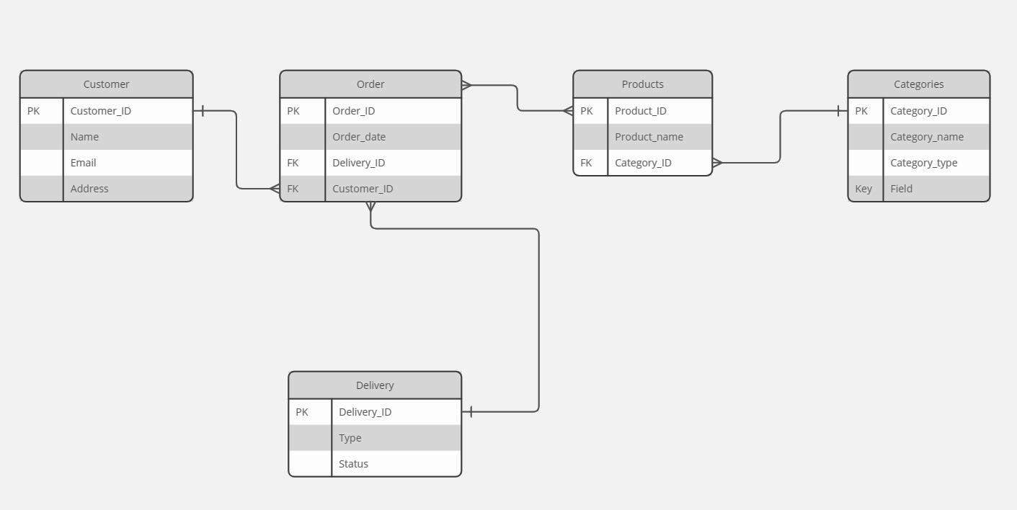

**Conclusion:**

In this case study, we delved into the design of Amazon's schema and Entity-Relationship diagram.This high-level ER diagram forms the foundation of understanding how Amazon’s platform functions, ensuring all aspects of the user experience, product management, and transaction processing are well-integrated.